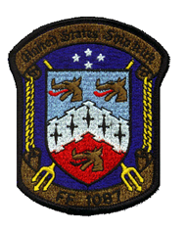
USS KIRK (FF/DE-1087)
2019 Reunion Agenda
Sept 18 – 22, 2019

Weds. Sept. 18: 1800 – 2200 Reception (in assigned meeting room)

Thurs. Sept. 19: 0800 – 1700 Self-guided tour Colonial Williamsburg (meet in
Lobby 0730) $41per person - purchase tickets online at www.colonialwilliamsburg.com
1800 – 2200 Social Networking (in assigned meeting room)

Fri. Sept. 20: 0800 – 1700 Self-guided tour Jamestown and Yorktown (meet in lobby 0730) $26 combo per person – purchase tickets online at www.historyisfun.org
1800 – 2200 Reunion Dinner (in assigned meeting room) $65 per person. By August 19th send payment to:
David Hyson
11402 Old Frederick Road
Marriottsville, MD 21104 (formal attire optional)

Sat. Sept 21: 1000 – 1200 Self-guided tour General MacArthur’s Memorial (meet in lobby 0830) Free (donations accepted)
1300-1700 Self-guided tour USS Nauticus/USS Wisconsin-Norfolk $16 Basic Ticket / $35 Gold Ticket per person
18:00 – 22:00 Social Networking (in assigned meeting room)

Sun. Sept 22: No formal gatherings. Impromptu breakfast. Depart reunion.

